Jodhamal Youth Conclave ‘22
Establishing morality in mayhem

BACKGROUNG GUIDE
UNITED NATIONS GENERAL ASSEMBLY (LEGAL)
AGENDA: Deliberating upon a legal framework of regulations apropos to military intervention with special emphasis on Responsibility to Protect.

CHAIRPERSON: KARMANYA WAHI
VICE CHAIRPERSON: ATIN WAZIR
RAPPORTEURS: SOHAM MAGAZINE, SANVI ARORA

On gloomy days and avaricious nights
When a country bleeds and people suffer the plight
Only a true leader can bring in a morning bright

Table of Contents

- Executive Board’s Surmise on the Agenda

- About the Committee

- Introduction to Agenda

- Case of Iraq

- Case of Kosovo

- Case of Rwanda

- Raid on Entebbe

- India Bangladesh War

Executive Board’s Surmise on the Agenda

In modern and contemporary world, the definition of invasion and intervention are empirically interchangeable, especially in geopolitical conflicts and situation. While etymologically, intervention means ‘the act or fact of becoming involved intentionally in a difficult situation1’ and invasion means ‘an occasion when an army or country uses force to enter and take control of another country2’; virtually, both challenge the Westphalian Sovereignty of a nation. Hence, in order to elucidate my arguments in this essay, I will be using both terms interchangeably.
To begin with, I would like to say that on moral and ethical grounds, it becomes the responsibility of every nation to protect human beings from crime against humanity and transgression of their basic human rights. Since 2005, the United Nations has endorsed ‘Responsibility to Protect’ or ‘R2P’ which inherently make member sates’ fundamental duty to protect human dignity and integrity, even at the cost of military intervention.
Though, Article 2(4)3 of UN Charter delineates non-intervention as its rudimentary meaning and makes invasion or intervention illegal in any scenario; however, Article 514 of Chapter VII of United Nations Charter gives inherent right to member states to act militarily in self-defence against any aggression. Since this article is vaguely defined, it gives member states a prerogative to launch a military intervention at the prospects of aggression from another member state.
Through this, United States and George Bush administration were able justify their invasion of Iraq and toppling of Saddam Hussein regime after the terror attacks of 9/11 on the prospects of arbitrary and barbaric region of Hussein, presence of WMDs or weapons of mass destruction and purported links with terror groups like Al-Qaeda. In this particular case, invasion was neither legitimate as it took place without the approval of United Nations Security Council nor was it morally justified as it caused mayhem in Iraq and increased the death toll from 70,000 in Saddam’s reign to 100,000 Iraqis and 4500 Americans in the aftermath.
While Iraq may have faced severe ramifications of intervention, Rwanda, on the other hand, had to bear the severe consequences of non-intervention of international community in 1994 which resulted in a genocide of Tutsi community5.
Even if we take the example of Kosovo armed conflict of 1999, we can observe that it was a battle for humanity and not territory, bereft of any cupidity. The harrowing campaign launched by Yugoslav President Slobodan Milošević’s forces against Kosovo Liberation Army who were seeking autonomy and independence lead to thousands of deaths and internal displacement of nearly 1.5 million people. The campaign’s modus operandi was to kill or expel as many as Kosovo Albanians as possible. It was “Serbrenica, all over again.”
The conflict would have exacerbated had NATO (North Atlantic Treaty Organization) not intervened with its air-strikes and economic sanctions. Though this was done without the approval of UN Security Council, yet, it was welcomed by the international community including Secretary General Kofi Annan. ‘This was morally legitimate.’
“We had to make clear that the rights of sovereign states to non-interference in their internal affairs could not override the rights of individuals to freedom from gross and systematic abuses of their rights.”-Former Secretary General of United Nations Kofi Annan
Through the examples of Rwanda and Kosovo, we have established that invading another country on the pretext of Responsibility to Protect is not only legitimate but also a fundamental duty of member states. We have also observed that it is important to discern the intentions of the member states in their exercise of R2P as we can see in the case of Iraq, acrimonious relations between George W. Bush administration and Saddam Hussein may have been a salient aspect of intervention.
Another example can be given of Muammar Gaddafi and Libya which was theoretically and legally legitimate as it occurred with the approval UN Security Council in 2013 and passing of Resolution 1973 and with aim of ‘precluding further attacks on civilians’. Michael Poznansky argues in his book ‘In the Shadow of International Law’ that the claim of the White House apropos to Gaddafi massacring people of Benghazi was antithetical to the reality. The New York Times reported that Gaddafi’s threats were aimed at rebel groups and not at civilians, he in fact was willing to give amnesty to all those who laid down their arms. The international intervention in Iraq and Libya were contingent upon their leaders’ acrimonious relationships with the west and not on fostering fraternity in a fractured world.
This observation eventually led to many jocular and facetious remarks such as “Oil is discovered in Antarctica. The murderous regime of penguins is going to be overthrown, says US Department of State.”
The above also explains the recalcitrance of the world community in engaging in crisis over East Timor. After the fall of Suharto, many regions of Indonesia long suppressed and deprived of their cultural identity started seeking autonomy. East Timor was one of them. In the referendum held, 78.4% voted for autonomy and this led to a massive violent conflict. Since US didn’t want to lose an important ally (Indonesia), it had to be emphatically pacified into pressurizing President B.J. Habibie to withdraw all Indonesian forces from East Timor. The international community’s reticence in engaging in Darfur is another vindication of the above observation.
We can conclude from the above arguments that it is legitimate for one country to intervene or invade another country with the intention of establishing peace at the hearth of chaos on the pretext of Responsibility to Protect.
“WE THE PEOPLE” in the United Nations Charter doesn’t distinguish between nationalities and hence, member states are given the responsibility of upholding Universal Declaration of Human Rights universally without any prejudice of nationalities.
Apart from R2P, other scenarios which allow countries to intervene is ‘right to rescue’ wherein each member state has a moral duty to protect and rescue its citizens envisaged in a conflict-ridden state. This may partially invade the sovereignty of the country but stands legitimate, both legally and morally. One of the most prominent examples of this is Raid on Entebbe in 1979 by Israel to rescue its citizens kept as hostages in Uganda. Idi Amin had allegedly supported the hijacking. During the Operation (Thunderbolt), Israel destroyed nearly 11 MIG-21s of Ugandan Air Force along with killing 45 soldiers of Ugandan Army. This
The third scenario, though has no legal framework or legitimacy, is when distress caused by the internal matters of a state effects its neighbouring state. For instance, the involvement of India in the Bangladesh Liberation War may well be justified as the influx of nearly 6 million Bangladeshi immigrants into West Bengal was causing acute distress to the Indian economy and infrastructure in 1971. The obstination of West Pakistan in denying political representation to East Pakistan sowed the seeds of disparity. Moreover, General Tikka Khan’s aggressive and violent policies in East Pakistan led to mayhem. Though India’s involvement in training Mukti Bahini (the Bangladeshi rebel group) and waging a war against Pakistan in 1971 was a breach of Pakistan’s sovereignty; it was again ethically and politically justified.
In peroration, one would assume that in the modern and contemporary world, the international community would have moral responsibility to intervene in conflicts to uphold the human dignity; sometimes invading another nation may be the only viable option but it should be done with the aim of rebuilding and not reshaping the state or its people. This act should be bereft of any avariciousness or greed. Fostering fraternity in a fractured world should be a moral navigator in international politics and the world should stand in morality over rapacity and solidarity over disparity. Through this, one would be able to justify the legitimacy of invasion of a country.
Note: The above stated essay is an overview of the topic and excerpts from the same should not be quoted in the committee. The above stated paragraph does not delineate the prespective of the conference.
The delegates are requested to be well-versed with the background guide. However, excerpts from the background guide cannot be presented as a viable proof in the committee.
Happy Researching
See you at the fall!!

At your disposal
Executive Board
ungalegal.jyc22@gmail.com

About The United Nations Legal

The General Assembly, which is constituted of representatives from each UN Member State, is the principal deliberative body on issues with regard to international law. Many multilateral treaties are adopted by the General Assembly and then made available for signature and ratification. The Legal (Sixth) Committee aids the General Assembly's work by giving substantive legal assistance. The Sixth Committee is the major forum for the General Assembly to examine legal issues. As one of the main committees of the General Assembly, all United Nations Member States are entitled to participation on the Sixth Committee.
The Committee discusses agendas like crimes against humanity, international terrorism and internationally treaty frame work and works to solve issues regarding the same with respect to the power it holds.
The United Nations General Assembly has an express mandate to promote the progressive development of public international law as laid out in the Charter of the United Nations. Specifically, Article 13 of the Charter states that the General Assembly has the authority to "initiate studies and make recommendations for the purpose of: (a) promoting international co-operation in the political field and encouraging the progressive development of international law and its codification."
Subsequent practice has interpreted this provision as a broad authorization to elaborate new treaties on the widest range of issues, to adopt them, and to recommend them to states for their subsequent signature, ratification or accession. While international law-making negotiations take place in a variety of specialized bodies of the United Nations, depending on their actual subject-matter, those negotiations related to general international law are usually held at the Sixth Committee.

For this year’s conference, the Agenda of the Committee shall be: Deliberating upon a legal framework of regulations apropos to military interventions with special emphasis on Responsibility to Protect.
The agenda will source a bright ray of debate that shall help the delegates understand legal framework and the very necessary involvement of the committee in matters such as military interventions.

Introduction to Agenda

- R2P (Responsibility to Protect)
Each individual State has the responsibility to protect its populations from genocide, war crimes, ethnic cleansing and crimes against humanity. This responsibility entails the prevention of such crimes, including their incitement, through appropriate and necessary means. We accept that responsibility and will act in accordance with it. The international community should, as appropriate, encourage and help States to exercise this responsibility and support the United Nations in establishing an early warning capability.
The international community, through the United Nations, also has the responsibility to use appropriate diplomatic, humanitarian and other peaceful means, in accordance with Chapters VI and VIII of the Charter, to help to protect populations from genocide, war crimes, ethnic cleansing and crimes against humanity. In this context, we are prepared to take collective action, in a timely and decisive manner, through the Security Council, in accordance with the Charter, including Chapter VII, on a case-by-case basis and in cooperation with relevant regional organizations as appropriate, should peaceful means be inadequate and national authorities are manifestly failing to protect their populations from genocide, war crimes, ethnic cleansing and crimes against humanity. We stress the need for the General Assembly to continue consideration of the responsibility to protect populations from genocide, war crimes, ethnic cleansing and crimes against humanity and its implications, bearing in mind the principles of the Charter and international law. We also intend to commit ourselves, as necessary and appropriate, to helping States build capacity to protect their populations from genocide, war crimes, ethnic cleansing and crimes against humanity and to assisting those which are under stress before crises and conflicts break out.
R2P stipulates three pillars of responsibility:
PILLAR ONE: Every state has the Responsibility to protect its populations from four mass atrocity crimes: genocide, war crimes, crimes against humanity and ethnic cleansing.
PILLAR TWO: The wider international community has the responsibility to encourage and assist individual states in meeting that responsibility.
PILLAR THREE: If a state is manifestly failing to protect its populations, the international community must be prepared to take appropriate collective action, in a timely and decisive manner and in accordance with the UN Charter.
- Legal Framework

The rules, rights and obligations of companies, governments, and citizens are set forth in a system of legal documents called a legal framework. Documents in the legal framework include a country’s constitution, legislation, policy, regulations and contracts. Laws and policy are supposed to have more authority than a contract. However, contracts can also be written to explicitly override the laws and regulations. Legal documents that cover broad principles, like constitutions, are generally more difficult to change. More specific documents, like laws and contracts, can often be more easily amended. Countries with detailed laws and policies often have more stable and predictable legal frameworks than those that leave more aspects open for negotiation in individual contracts.

- Meaning of Military Intervention, military invasion and Westphallian Democracy
International military intervention is the movement of troops or forces of one country into the territory or territorial waters of another country, or military action by troops already stationed by one country inside another, in the context of some political issue or dispute. While an invasion is a military offense in which large numbers of combatants of one geopolitical entity aggressively enter territory owned by another such entity, generally with the objective of either: conquering; liberating or re-establishing control or authority over a territory; forcing the partition of a country; altering the established government or gaining concessions from said government; or a combination thereof. An invasion can be the cause of a war, be a part of a larger strategy to end a war, or it can constitute an entire war in itself. Due to the large scale of the operations associated with invasions, they are usually strategic in planning and execution.
The basis of modern international relations was established by the 1648 Westphalian Peace Treaties, which mark the birth of nation states as the privileged and primary actors, replacing the medieval system of centralized religious authority with a decentralized system of sovereign states as the sole legitimate form of sovereign authority. The Westphalian state-centric system was based on some new principles, including the sovereignty, sovereign independence and equality of the nation states, territorial integrity, the equal rights and obligations of the states, non-intervention in others’ domestic affairs, and the conduct of inter-state diplomatic relations through embassies, among many others. Power was at the center of this system to regulate inter-state relations in the absence of any higher systemic authority. As Michael Vaughan argues, the Westphalian order was important for three reasons. First, it secularized international politics and anchored it on the Understanding the Distinguishing Features of Post-Westphalian Diplomacy 177 tenets of national interests. Second, it introduced the concept of sovereignty and the privileged status of the states without any higher authority standing above them, unless the state voluntarily assents to such an authority. Third, it accepted the states as sovereign supreme authorities within their borders with legitimate authority over all inhabitants living there, and promoted a conception of international society based on the legal equality of the states. Referring to this difference between internal and external sovereignty, domestic politics and foreign policy emerged as two distinct and independent domains for the nation states. Thus, the emergence of similar contrasts, i.e. between national and international, internal politics and foreign policy, world politics and world economics, inside and outside, etc., has become one of the characteristics of the Westphalian system
Iraq

The Iraq War was a protracted armed conflict in Iraq from 2003 to 2011 that began with the invasion of Iraq by the United States–led coalition that overthrew the Iraqi government of Saddam Hussein. The conflict continued for much of the next decade as an insurgency emerged to oppose the coalition forces and the post-invasion Iraqi government. US troops were officially withdrawn in 2011. The United States became re-involved in 2014 at the head of a new coalition, and the insurgency and many dimensions of the armed conflict continue today. The invasion occurred as part of the George W. Bush administration’s War on terror following the September 11 attacks.
In October 2002, Congress granted Bush the power to decide whether to launch any military attack in Iraq. The Iraq War began on 20 March 2003, when the US, joined by the United Kingdom, Australia, and Poland, launched a "shock and awe" bombing campaign. Iraqi forces were quickly overwhelmed as coalition forces swept through the country. The invasion led to the collapse of the Ba'athist government; Saddam Hussein was captured during Operation Red Dawn in December of that same year and executed three years later. The power vacuum following Saddam's demise and mismanagement by the Coalition Provisional Authority led to widespread civil war between Shias and Sunnis, as well as a lengthy insurgency against coalition forces. The United States responded with a build-up of 170,000 troops in 2007. This build-up gave greater control to Iraq's government and military, and was judged a success by many. In 2008, President Bush agreed to a withdrawal of all US combat troops from Iraq. The withdrawal was completed under Barack Obama in December 2011

Kosovo
Twenty-two years ago, the first bombs fell on the Federal Republic of Yugoslavia during the night of March 24, 1999. Over the next seventy-eight days, NATO aircraft flew over 10,000 strike sorties and dropped some 23,000 bombs. This was a significant effort; by comparison, during the First Gulf War, coalition forces flew almost 12,000 strategic sorties over six weeks.
NATO hoped to stop a campaign of ethnic cleansing carried out by Serbian military and paramilitary forces against Albanian Kosovars. As NATO Secretary General Javier Solana stated, Operation Allied Force sought “to halt the violence and to stop further humanitarian catastrophe.” Over the course of the crisis, approximately 950,000 Kosovars fled into Albania, Macedonia, and Montenegro. Almost 600,000 became displaced within Kosovo. In total, some 90 percent of the Kosovar population fled their homes in the war.
Kosovo is a tantalizing case of success. Even today Kosovar Albanians speak favorably of America and NATO. After NATO forces reached Gjakova, Agim Byçi recalled that “then began joy, merriment and bliss, life, freedom, and gratitude for the European Union and especially for America.” Under certain circumstances, and with enough commitment, military intervention can work and save lives. But we need to look beyond the assumption that our decisions and actions determine success or failure, and instead make sure the dynamics of the local conflict are conducive to an intervention. Ultimately, not all problems can be solved with military force. NATO envisioned Operation Allied Force as a three-day bombing campaign to quickly cause Milošević to acquiesce to NATO’s demands. NATO planners based the campaign on Operation Deliberate Force, a two-week operation in Bosnia that rapidly brought Serbian forces to the negotiating table at Dayton. Allied Force was supposed to be a similarly swift jolt of reality to bring Milošević to his senses. The bombing campaign had a strong start, with aircraft attacking from bases in Italy, Germany, the United Kingdom, and the U.S. On the first day, NATO even shot down three MiG-29s, Serbia’s most advanced fighter. But Milošević did not give in. Soon NATO leaders agreed to allow intensified bombing and approved a larger target list. By May 1, NATO was flying about 200 combat sorties a day. They bombed petroleum refineries, lines of communication, power grids, dual-use communications structures, bridges, and roads. But NATO forces were destroying targets faster than they could be approved. By the end of the campaign, NATO had the resources to conduct 1,000 combat sorties a day but lacked sufficient targets.[22]
As the conflict dragged on and Serbian ethnic cleansing continued, the strategic rationale behind Allied Force crumbled. A coercive bombing campaign is ill-suited to stopping ethnic cleansing. Rather than seeking complete military victory, Robert Pape explains, “The key to success in conventional coercion is...the ability to thwart the target state’s military strategy for controlling the objectives in dispute. To succeed the coercer must undermine the target state’s confidence in its own military strategy.”[23] In this case, Operation Allied Force aimed to change Milošević’s strategic calculus by increasing the cost of his ethnic cleansing campaign. Just two days into Operation Allied Force, General Wesley Clark, Supreme Allied Commander Europe (SACEUR), warned CNN, “It was always understood from the outset that there was no way we were going to stop these paramilitary forces who were going in there and murdering civilians.”[24] Bombing campaigns—even with the best precision weapons—are best at hitting hard targets or large-scale units–like tank formations, heavy artillery, or massed infantry. Small units armed with AK-47s or just machetes are sufficient to carry out ethnic cleansing. Those are hard to spot and bomb. Milošević dispersed his troops into the general population, making it impossible for NATO to bomb them without unacceptable civilian casualties while still maintaining full operational capacity.[25] Serbian forces also used urban areas and Kosovo’s rugged terrain to their advantage.
View fullsize
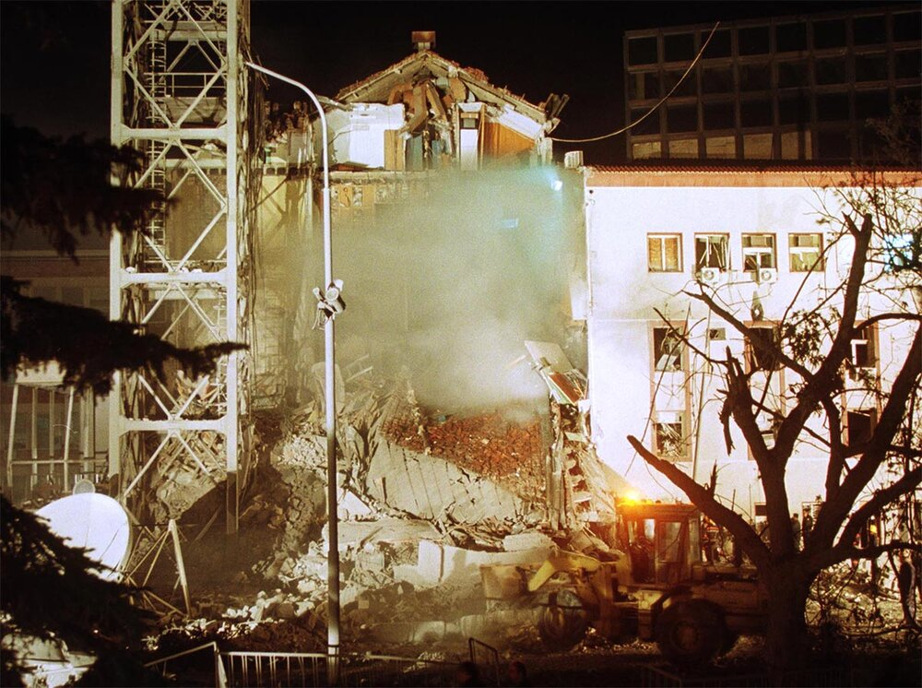
The aftermath of a missile strike on the government-run studios of Radio Television Serbia (RTS) in Belgrade. (Emil Vas/Reuters)
After 78 days of bombing, NATO and Serbia signed the Military Technical Agreement on June 9. The agreement ordered the cessation of hostilities by Yugoslav and Serb forces, laid out the phased withdrawal of those forces from Kosovo, and established NATO’s peacekeeping force, Kosovo Force.[26] After confirming that “the full withdrawal of the Yugoslav security forces from Kosovo has begun,” on June 10, NATO Secretary General Javier Solana ordered a suspension of NATO bombing operations.[27]
On June 12, NATO forces entered Kosovo and with them came the first of the returning Kosovar refugees. By the end of August, almost all of the refugees had returned to Kosovo. NATO’s job was not done though

Rwandan Genocide

Code Cable, 11 January 1994.
To: Maurice Baril, DPKO, UN, New York.
From: Romeo Dallaire, Force Commander, UNAMIR,
Kigali, Rwanda.
Subject: Request for protection of informant.

Force Commander put in contact with informant by
very very important government politician. Informant is
a top level trainer in the cadre of interahamwe-armed
militia of MRND [the ruling Hutu political party]. He
informed us he was in charge of last Saturday’s
demonstrations . . . [There] they hoped to provoke the
RPF battalion [the unit of the rebel army stationed in
Kigali as part of the peace agreement] to engage
(being fired upon) the demonstrators and provoke a
civil war. Deputies were to be assassinated upon entry
or exit from Parliament. Belgian troops [the core
component of the peacekeeping force] were to be
provoked and if Belgian soldiers resorted to force a
number of them were to be killed and thus guarantee
Belgian withdrawal from Rwanda . . . Since the
UNAMIR mandate he [the informant] has been ordered
to register all Tutsi in Kigali. He suspects it is for their
extermination. Example he gave was that in 20
minutes his personnel could kill up to 1,000 Tutsis.
Informant states he disagrees with anti-Tutsi
extermination . . . Informant is prepared to provide
location of major weapons cache with at least 135
weapons . . . He was ready to go to the arms-cache
tonight . . . It is our intention to take action within the
next 36 hours . . . Recce of armed cache and detailed
planning of raid to go on late tomorrow. Possibility of a
trap not fully excluded . . . Peux Ce Que Veux. Allons-Y.
-KOFI ANAN,INTERVENTION

Starting April 6, 1994, and during 100 days, the Hutu majority murdered 800,000 Tutsis, or 11 percent of the population, and 84 percent of the Rwandan Tutsi. 1 The atrocities begun the day President Habyarimana’s plane was shot down. The next day, 10 Belgium UN Assistance Mission for Rwanda (UNAMIR) peacekeepers were assassinated in order to force a withdrawal. UNAMIR was sent to implement the peace process in Rwanda. The main countries supporting the 2,500 UN force eventually pulled out, including the United States. A new mission, UNAMIR II, was finally authorized by the UN on May 17, 1994, but troops arrived as late as August, or one month after the end of the genocide. The Clinton administration agreed to send a small force in Rwanda to deal with the humanitarian consequences of the genocide. A minority of 34 percent of the American people approved of a US intervention.
It is generally agreed that the international community failed in its responsibility to intervene in the genocide in Rwanda. (104) Kenneth Kaunda, the former President of Zambia, has said "I do not know how we could have sunken to that situation with the rest of the world watching and doing nothing about it. I think it is unforgivable. I do not know how we can ever explain that." According to some, the United States, France, Belgium, Germany, and the United Nations in particular deserve censure for standing by despite having significant knowledge of what was occurring inside Rwanda.What facilitated this lack of response by Western governments, who could have easily helped to try to stop the genocide then occurring in Rwanda?
While the U.N. Convention on the Prevention and Punishment of Genocide does not provide a specific mechanism for intervention in situations of genocide, it has been argued that there is nonetheless a duty to intervene. Article 8 of the Convention states that "any Contracting Party may call upon the competent organs of the United Nations to take such action under the Charter of the United Nations as they consider appropriate for the prevention and suppression of acts of genocide." Thus, when genocide occurs, states party to the Convention should take action to prevent and suppress it.
The United Nations was perhaps best equipped to intervene in Rwanda. Indeed, throughout 1993, recommendations were made to the Security Council to send a peacekeeping force to the country. Even U.N. Secretary-General Boutros Boutros-Ghali argued in favor of sending a peacekeeping force, as Rwanda was seen to be on fragile ground during the negotiation, and the immediate aftermath, of the Arusha Accords. On October 5, the U.N. Security Council (Security Council) passed Resolution 872 in an attempt to help, but it was an inadequate response to the deteriorating situation on the ground in Rwanda.

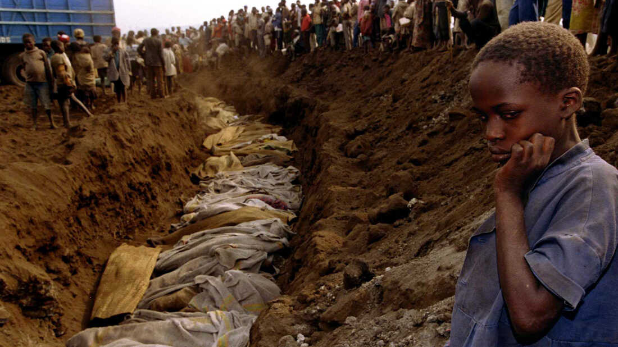

Right to Rescue (Raid on Entebbe)

Operation Entebbe or Operation Thunderbolt was a counter-terrorist hostage-rescue mission carried out by commandos of the Israel Defense Forces (IDF) at Entebbe Airport in Uganda on 4 July 1976.
A week earlier, on 27 June, an Air France Airbus A300 jet airliner with 248 passengers had been hijacked by two members of the Popular Front for the Liberation of Palestine – External Operations (PFLP-EO) under orders of Wadie Haddad (who had earlier broken away from the PFLP of George Habash), and two members of the German Revolutionary Cells. The hijackers had the stated objective to free 40 Palestinian and affiliated militants imprisoned in Israel and 13 prisoners in four other countries in exchange for the hostages. The flight, which had originated in Tel Aviv with the destination of Paris, was diverted after a stopover in Athens via Benghazi to Entebbe, the main airport of Uganda. The Ugandan government supported the hijackers, and Dictator Idi Amin, who had been informed of the hijacking from the beginning, personally welcomed them. After moving all hostages from the aircraft to a disused airport building, the hijackers separated all Israelis and several non-Israeli Jews from the larger group and forced them into a separate room. Over the following two days, 148 non-Israeli hostages were released and flown out to Paris. Ninety-four, mainly Israeli, passengers along with the 12-member Air France crew, remained as hostages and were threatened with death.
The IDF acted on information provided by the Israeli intelligence agency Mossad. The hijackers threatened to kill the hostages if their prisoner release demands were not met. This threat led to the planning of the rescue operation. These plans included preparation for armed resistance from the Uganda Army.
The operation took place at night. Israeli transport planes carried 100 commandos over 4,000 kilometers (2,500 mi) to Uganda for the rescue operation. The operation, which took a week of planning, lasted 90 minutes. Of the 106 remaining hostages, 102 were rescued and three were killed. The other hostage was in a hospital and was later killed. Five Israeli commandos were wounded, and one, unit commander Lt. Col. Yonatan Netanyahu, was killed. Netanyahu was the older brother of Benjamin Netanyahu, who would later become Prime Minister of Israel. All the hijackers and forty-five Ugandan soldiers were killed, and eleven Soviet-built MiG-17s and MiG-21s of Uganda's air force were destroyed. Kenyan sources supported Israel, and in the aftermath of the operation, Idi Amin issued orders to retaliate and kill Kenyans present in Uganda. As a result, 245 Kenyans in Uganda were killed and 3,000 fled the country.
Operation Entebbe, which had the military codename Operation Thunderbolt, is sometimes referred to retroactively as Operation Jonathan in memory of the unit's leader, Yonatan Netanyahu.

Indo-Pak War 1971 And Creation of Bangladesh

Prior to Bangladesh Liberation War in 1971, India had no plans for large scale military action in East Pakistan. Since the Sino-Indian War of 1962, the primary objective of the Indian Army Eastern Command was the defense of the Indian northern and eastern borders, defending the "Shiliguri Corridor", and on combating insurgencies raging in Mizoram, Nagaland, Manipur and the Naxalites in West Bengal. Pakistani Eastern Command plan for the defense of East Pakistan between 1967 and 1971. A generic representation, some unit locations are not shown.
Since 1948 bulk of the Pakistani armed forces were stationed in West Pakistan and the strategic role of the forces in East Pakistan was to hold out until Pakistan defeated India in the west. The Pakistan Army Eastern Command had planned to defend Dhaka until the last by ultimately concentrating their forces along the "Dhaka Bowl", the area surrounded by the rivers Jamuna, Padma and Meghna
The main reason Maj. Gen. Rao Farman Ali and Lt. Gen. Sahibzada Yaqub Khan had opposed military action against Bengali civilians was the fear of an Indian attack, which the Pakistan army was woefully unprepared to meet in March 1971. The 14th infantry division with its brigades posted at Comilla (53rd), Dhaka (57th), Rangpur (23rd) and Jessore (107th) was the only Pakistani unit in East Pakistan prior to March 1971. The issue of direct military intervention was discussed between the Indian military and political leadership in April 1971. Although some Indian officers expected early intervention, Indian army command decided against immediate intervention, and concluded that a full attack could only take place after 15 November at the earliest and only after deliberate and extensive preparations. Indian Army Eastern Command took over responsibility for East Pakistan operations on 29 April and on 15 May launched Operation Jackpot, a full-fledged operation to arm, train, equip, supply and advice the Mukti Bahinifighters engaged in guerrilla warfare against the Pakistan armed forces.

